Created a User Form in Wordpress

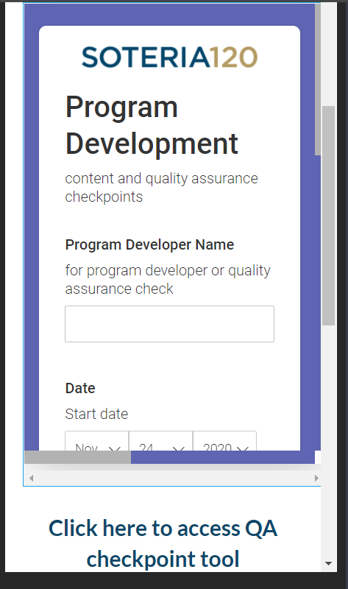

EMBED with a custom HTML

LOGO GOES HERE

LINK to tool for data cllection